Peltier Sandwich

The following is a list of parts and materials with sources. I've also included a
template of the hot and cold plates and the insulation.

Materials
Heat sink (Main)
Fullway pin type (presently unavailable in US)
5 ounces and a surface area of about 110 sq. in.

I am currently looking into a suitable replacement for the Fullway sink. I'll let you know when I find one.

Fans
(2) 50mm X 10mm heat sink fans (your choice)
Use 3 wire fans if you want to monitor RPM.

Heat sink (Rear)
Aavid Mfr P/N 960-87001
(You may substitute one of the cooler plates for this sink.)

Peltier
Part #: 580-0052 30mm X 30mm X 3.3mm TEC
127 element Peltier device. 3 Amp, 25 Watts.
It draws about 2 amps at 12 volts in my system.

"Y" Adapter (to connect peltier to HD power cable) Radio Shack
Part # 278-780 can be adapted.

Plates
3/16" aluminum sheet stock
Try a local metal jobber or electronic component surplus house.
I picked up a used case with enough for about 30 plates for $12.

Screws, nuts, washers, and springs
(4) 6-32 X 1 1/2" flat-heat machine screws
(4) 6-32 nuts
(4) #6 flat washers
(4) #3 brass "finish washers" (used as top spring retainer)
(4) 1/4" X 1/2" X.040 coil springs
These are available from your local hardware center.

•Hot, Cold, and/or Rear Plate

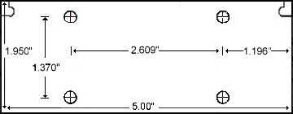

These plates are cut from 3/16" aluminum sheet stock. The notches on the upper corners are not cut.

Foam Insulator

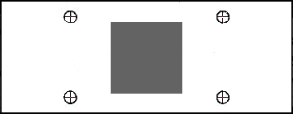

The insulation is cut from the lid of a styrofoam egg carton. This was about the perfect thickness for the 3.3mm TEC I purchased from Meci Surplus. The edges may be trimmed back a 1/4" or so if you find they interfere with mounting into the PII mounts on the motherboard.

The cut-out in the center is sized at 31mm for a 30mm X 30mm TEC. Adjust if necessary.

Wiring
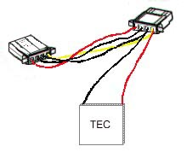
The TEC was wired to a 486 heat sink fan splitter cable I had left over. The splitter is attached in between the hard rive and its power connector. The yellow splitter wire is +12 volts and the black is ground. The positive TEC wire (red) is connected to the yellow and black to black. Make sure you power up the TEC to check which side is the cold side before mounting it. Don't run it for longer than necessary to determine which is hot and which is cold.

Assembly

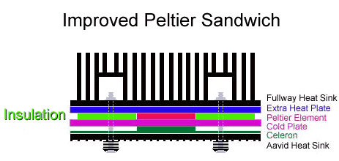

A hack saw with a 24 tooth per inch blade will suffice for cutting the plates. I used an 10" aluminum cutting
blade on my table saw. The holes are drilled to a diameter of 7/32", but a little larger hole will allow for some
adjustment if the holes do not come out exactly aligned.

It is important that the mating surfaces are flat and as smooth as you can get them. This is especially important
for mounting the heat plate to the heat sink. As I discussed in the Celeron article, I use successively finer and finer grades of wet / dry sand paper taped to a piece of glass or other flat surface to lap the surfaces flat. Before applying thermal compound to the surfaces, you should not be able to see any gap between the plate and sink when held up to a light. If you come across a heat sink with a thick base (> 3/8"), the heat plate will probably not be necessary.

There is not too much to the assembly once the plates are cut and drilled. Make sure that the peltier is installed with the cold side facing the Celeron and that a thin coat of thermal paste is applied between each metal surface. Tighten the screws in an "X" pattern to keep the pressure constant and to avoid crushing the TEC. Once the springs are about half way compressed, twist the plates and SEPP back and forth a few times to even out the thermal paste and then tighten the screws until the springs are almost entirely compressed.

If you decide to build this project, drop me an email and let me know of the outcome. I'd be interested to get some more input on the success rates.

Jim

•

•
• © '99 Jim Fager - jim@benchtest.com

